36. What is EtherChannel Misconfiguration?
- EtherChannel misconfiguration happens when member interfaces do not match the required configuration.
- As a result, the switch cannot bundle the interfaces into the Port-Channel.
- You will see errors like:
  - EC-5-CANNOT_BUNDLE2
  - interfaces go into suspended state
  - Port-channel stays down/down
- Mismatched configs can be on the same switch or between two switches.
- Troubleshooting EtherChannel = finding and fixing these mismatches.

🔵 2. Why do we need to troubleshoot EtherChannel?
:
- Because EtherChannel won’t form if configuration is incorrect.
- Traffic will not load balance, causing congestion.
- STP may block ports if channel is broken.
- A down EtherChannel can cause network outage between switches.
- Stability and redundancy depend on a correctly formed Port-Channel.
- Troubleshooting ensures loose links, speed mismatch, or VLAN mismatch are corrected.

🔵 3. Advantages of troubleshooting EtherChannel
:
- Ensures Port-Channel forms correctly.
- Helps identify misconfigured VLANs before outage.
- Prevents interfaces from entering suspended/err-disabled state.
- Assures proper load balancing.
- Reduces downtime by fast detection of problems.
- Ensures link redundancy is active.
- Helps STP stability.

🔵 4. Disadvantages / Challenges ()
- EtherChannel has strict requirements, easy to misconfigure.
- Hard to troubleshoot when many interfaces are in the bundle.
- Mismatch on one member link → entire EtherChannel unstable.
- Sometimes issues exist on remote switch — requires checking both sides.
- Difficult when using LACP/PAgP and modes mismatch.
- Errors may be misleading (e.g., VLAN mask error).
- Troubleshooting requires knowledge of:
  - interface mode
  - trunk VLANs
  - speed/duplex
  - channel-group mode
  - STP settings

Configuration:
en
conf t
hostname INBOM25CS01
int range Gi1/0/1 - 2
description Connected to INBOM25CS02
switchport mode trunk
switchport trunk allowed vlan 10
channel-group 1 mode active
ex

interface port-channel 1
switchport mode trunk
switch trunk allowed vlan 10
end

============================

en
conf t
hostname INBOM25CS02
int range Gi1/0/1 - 2
description Connected to INBOM25CS01
switchport mode trunk
switchport trunk allowed vlan 20
channel-group 1 mode active
ex

interface port-channel 1
switchport mode trunk
switch trunk allowed vlan 20
end
=============================================
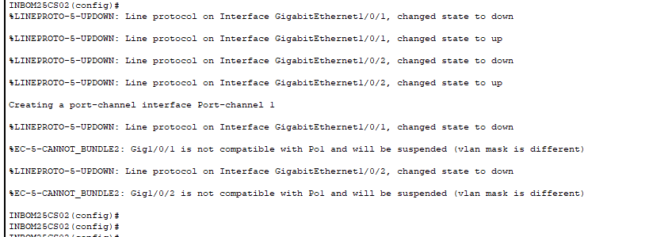
Above are wrong Configuration is represent the above error
the rule of ether channel is to have same configuration to both end

